|  |
| --- |
| **QUALITY ENHANCEMENT VISIT (QEV)****SUPPORTING GUIDANCE** |

|  |
| --- |
| **Document Owner:** Student Learning & Academic Registry  **Version number: 1.0**  **Effective date:** September 2024 (Academic Year 2024-25)  **Date of next review:** July 2025  *This document is part of the University Quality Framework, which governs the University’s academic provision.*  *This document should also inform the Continuous Monitoring and Enhancement processes.* |

|  |
| --- |
| **QUALITY ENHANCEMENT VISIT (QEV) -** **SUPPORTING GUIDANCE** |

1. **Purpose**

This document is intended to support Link Tutors through the Quality Enhancement Visit (QEV) process including organising and undertaking a QEV, recording and reporting, approval and action planning and communication of outcomes to Partners and a timeline of key activities.

As stated in the Teesside University (TU) Quality Framework – QEV reports are approved as part of the annual Continuous Monitoring and Enhancement (CME) process. Key points from the reports are used (alongside other metrics) to inform the Partner Report **D1-Annex 4**.

[**Chapter D1 of the Quality Framework**](https://www.tees.ac.uk/sections/about/public_information/quality_framework.cfm) provides guidance on the current processes for CME at the University.

All Partnership Provision should have an annual QEV including TNE, Employer Partners and TUCP. This should help to inform the Partner report.

Quality Enhancement Report Partner Report

1. **Undertaking the QEV**

* QEV’s for the current academic year should take place in Semester 1 of the intake’s delivery (where possible). This may not always be possible due to schedule of visits such as international travel – however every effort should be made to meet this deadline which may mean QEV’s take place virtually if required (i.e., for TNE).
* It is the Link Tutor’s responsibility to organise and conduct the QEV. Further guidance and support on this can be found in the [**Link Tutor Guidance Document Section 5**.](https://liveteesac.sharepoint.com/:b:/r/sites/TM_LinkTutorNetwork/Shared%20Documents/General/Link%20Tutor%20Guidance%20Document%202023Approved%20April%202023_update%201%20042024.pdf?csf=1&web=1&e=5PHfG8)
* If this is not possible i.e., Associate Dean (International) or other School nominee is visiting a TNE partner, the Link Tutor should be consulted and briefed on the outcomes of the report including the agreed Action Plan.
* Link Tutors can use the [**Link Tutor Network**](https://teams.microsoft.com/l/team/19%3A4bwBTNAdJvCLO-p1gQKV9qFhXfbym4ZvomXAzYd5XnE1%40thread.tacv2/conversations?groupId=d9d722cb-c3f2-4e0c-bc1b-4ffc44e24406&tenantId=43d2115b-a55e-46b6-9df7-b03388ecfc60)to consult with other Link Tutors across the institution and in different academic School’s regarding the organisation of the visit.

*For example, if SSSHL were undertaking a visit at Darlington College, this could be done in conjunction with other School’s to better use the resource and time of the partner staff involved.*

* Where possible, staff should also look to group courses within one visit. For example, TUIBS undertaking a visit to MDIS would look at all courses delivered there for their School.

1. **Completing the Form**

* The QEV form and associated Action Plan (**see Appendix 1**) should be completed during the visit in conjunction with the appropriate partner staff.
* Link Tutor name plus person conducting the report (if different) both need to be added to the report form in Section A.

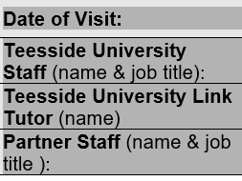

* All sections should be completed on the QEV Form.
* If the answer to Section 5 is **No**, this should be addressed as an action and CV’s sent to SSLESC for immediate approval.

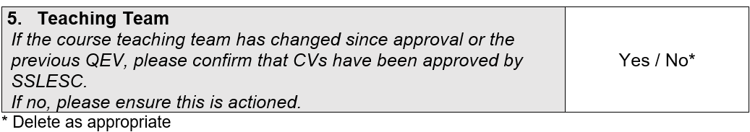

* Any previous actions not completed from prior report should be included in Section 1 of the Action Plan (**see Appendix 1**).

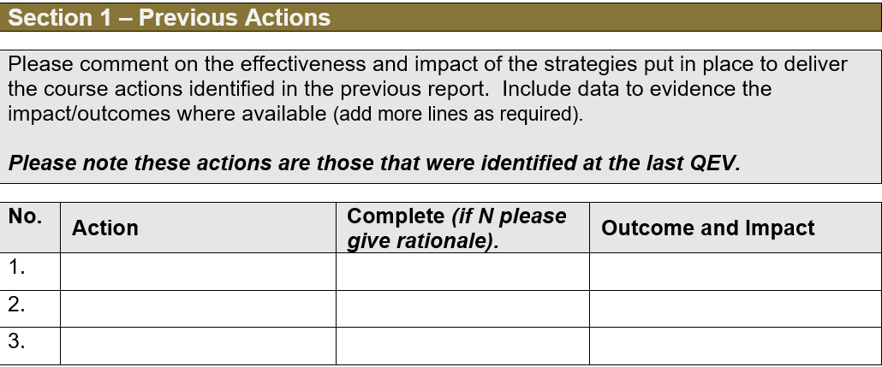

* QEV reports will not be accepted without a completed Action Plan - Section 2 of the Action Plan (**see Appendix 1**).

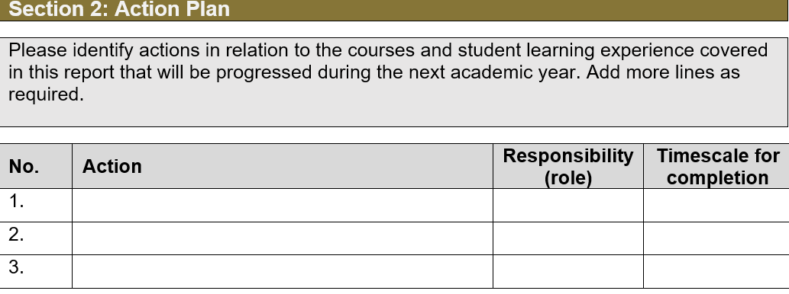

* All actions must be agreed by Partner and TU Staff

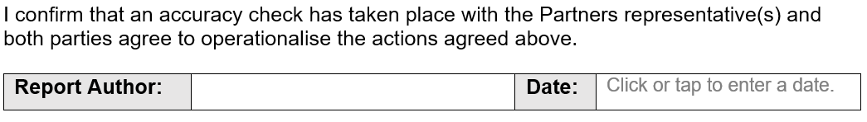

1. **Action Planning and Approval**

* Action Planning should be added in from previous years and discussed at the QEV as to resolution and responsibilities for the action. If action has not been completed this should be moved onto the next year’s agreed actions and a timeline for completion agreed.
* New actions should be agreed and completed on the form.
* Both TU and Partner staff should be in agreement with the actions, and these should be circulated afterwards to all involved parties.
* Link Tutors will be invited to SSLESC to present the report (they should be briefed in advance if they did not undertake the visit).
* Actions will be noted and agreed at SSLESC, and the approved reports will be stored on the Link Tutor Network alongside a template for recording actions. The APR team will populate this. Link Tutors should note when an action is complete.

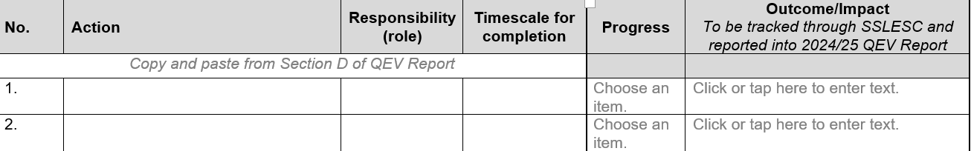

* 1. **Benefits to the Enhancements**

|  |  |
| --- | --- |
| Greater collaboration with Link Tutors to provide a consistent service delivery and better use of partner time/resource. | Grouping of courses to better use resource within the partnership provision. |
| Link Tutors to be informed and up to date with partner issues via the QEV report and presentation at SSLESC to be able to progress actions in a timely manner. | A more cohesive approach to tracking and ensure that partnership provision is adhering to TU processes i.e., CME. |
| A more useful summary of quality at partnership provision via the Partnership Quality Assurance Annual Review – in case of audits such as OfS. | Clearer action planning and closing of the loop regarding actions to be taken. |

1. **Timeline/Responsibility**

|  |  |  |
| --- | --- | --- |
| **Month** | **Activity** | **Responsibility** |
| August – mid September | Deadline for previous academic year QEV reports. | Schools |
| September – March | CPD - Undertaking an Effective QEV | Partnership & Project Manager (ACD)/Link Tutors |
| September/October | Upload tracker to Link Tutor site to inform of which QEV’s need to be undertaken. | Partnership & Project Manager (ACD) |
| October | Present 23/24 Partnership Quality Assurance Annual Review to SLEC for approval. | Assistant Academic Registrar (QAV) |
| October | Reminder to Schools and Link Tutors (via Link Tutor Network) re SSLESC dates for QEV report approvals. | Partnership & Project Manager (ACD)  APR (SLAR) |
| November onwards | QEVs begin to take place for **current** academic year. | School Link Tutors |
| February and May | Further reminder to Link Tutors for completion. | Partnership & Project Manager (ACD) |
| June/July | Final opportunity for 24/25 QEV reports to be approved at SSLESC meetings.  *This would include May intakes where possible.* | APR  School Link Tutors |
| June/July | Populate Partnership Quality Assurance Annual Review spreadsheet with 24/25 outcomes from QEV reports. | Quality Manager (QAV)  Partnership & Project Manager (ACD) |
| August – mid September | Any outstanding reports plus June/July delivery must be presented at September SSLESC at the latest. | School Link Tutors |

**KEY for Responsibility**

Schools

SLAR

1. **Further Support**

* CPD sessions will be delivered by the Partnership and Project Manager (SLAR) on good practice when conducting a QEV, writing the report and presenting the actions. Partner staff are also to be included in this CPD to gain their insight.

[**For more information and to book please click here**.](https://blogs.tees.ac.uk/lteonline/slar-cpd-offer/)

* The Link Tutor Network Team site is a source of support and collaboration and houses the [**Link Tutor Toolkit**.](https://wakelet.com/i/invite?code=9ijcwyse)